Name: __________________________________________________ Block: _____ Date: ___ /___ /___ Points: ______

Design Your Own Boxcar
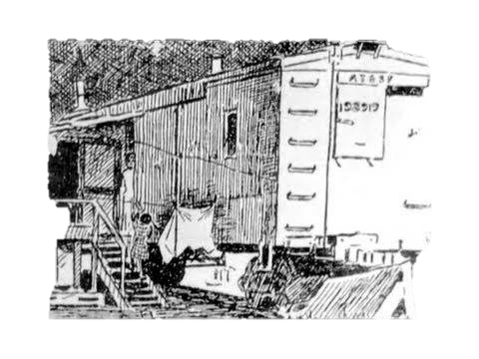

This mini project will allow you to design a boxcar home for your own family. Think about the conditions that the boxcar people were put under and how difficult it was to maintain and create a space that would be efficient for everyone. This project allows creative freedom and artistic abilities. Consider the following when designing your boxcar…
- How many people would be living in your home?
- How many adults and how many children?
- What kinds of labor could your family do to add to your home?
- How much space will you need and where will certain things go?

Directions:
- Create your family (# of people, male/female, children or adult)
- What kinds of jobs do you or your family members work on the railroads? (Traquero, gandy-dancer, cook, laundry)
- What camp was your boxcar located in? Where within that camp? (Close to the railroads?)
- What did your daily life look like?
- Create a diagram & arrange the house to fit your family’s needs: Windows, doors, potbelly stoves, bathrooms located outside, beds, porch, etc.
- Build a 3D model of your boxcar.
  - Teacher provides materials (Styrofoam boards, popsicle sticks, hot glue, paint, markers, lasagna noodles for texture of roofs, mini pieces of wood, various shapes/objects, etc.)
  - Ask teacher for specific materials if needed.
Ex:
BED
BED
Couch/Seating

Door
Window
Stove
Storage
BED
BED

